ARP Poisoning Lab

Ryan Coon

CYB-505

Professor Devin Ogg

August 14, 2024

Part 1:

Screenshots:

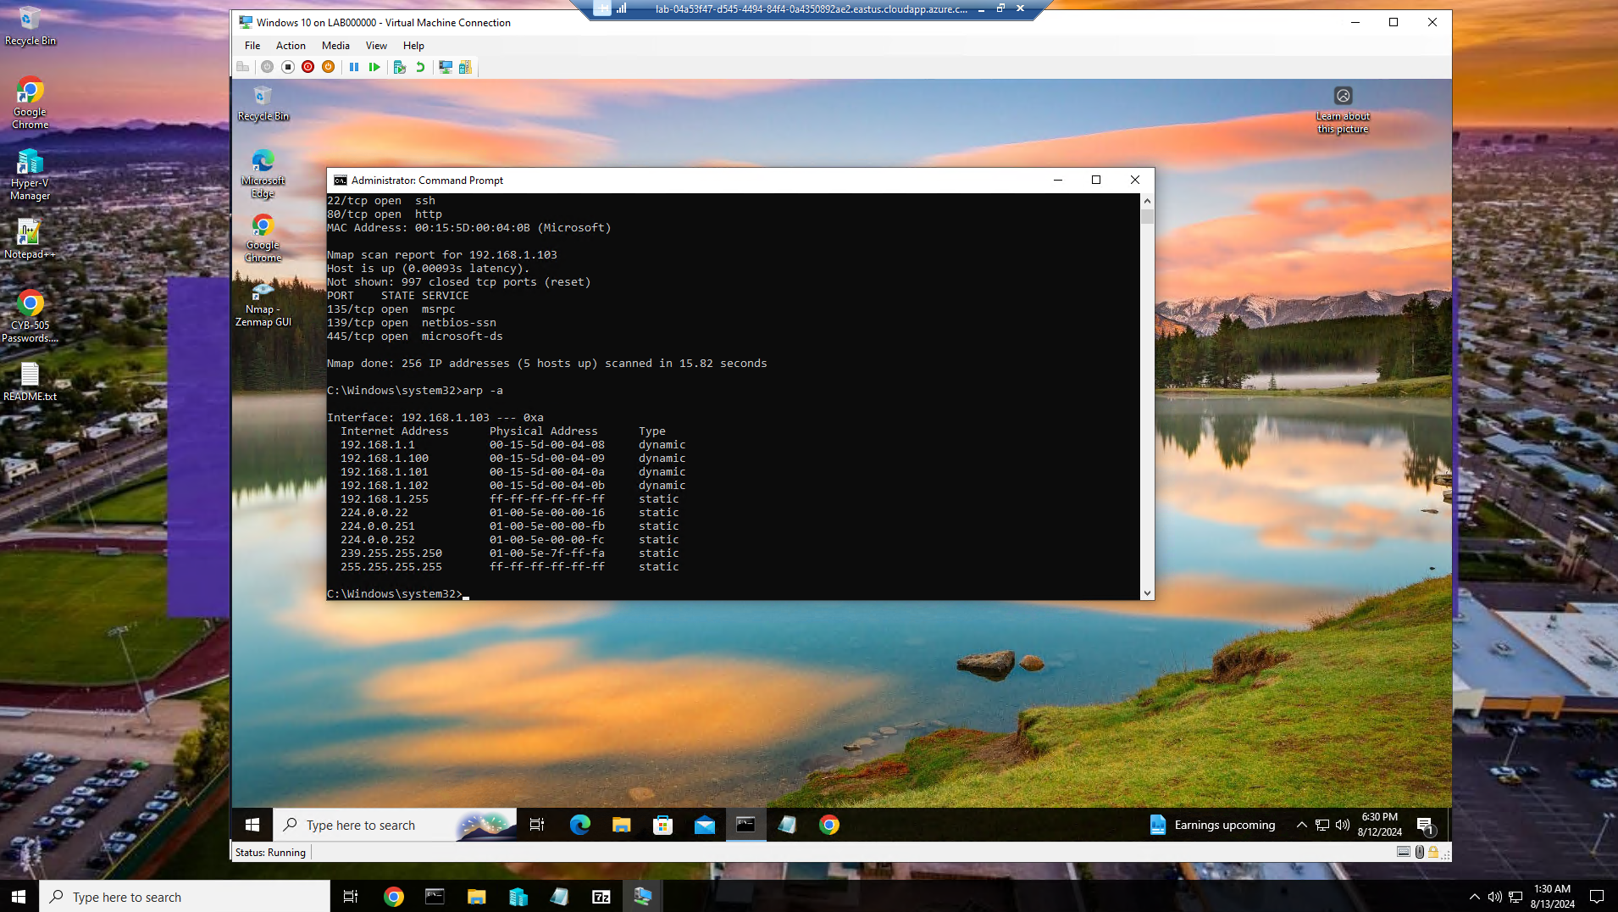

Initial ARP table as shown from Windows 10

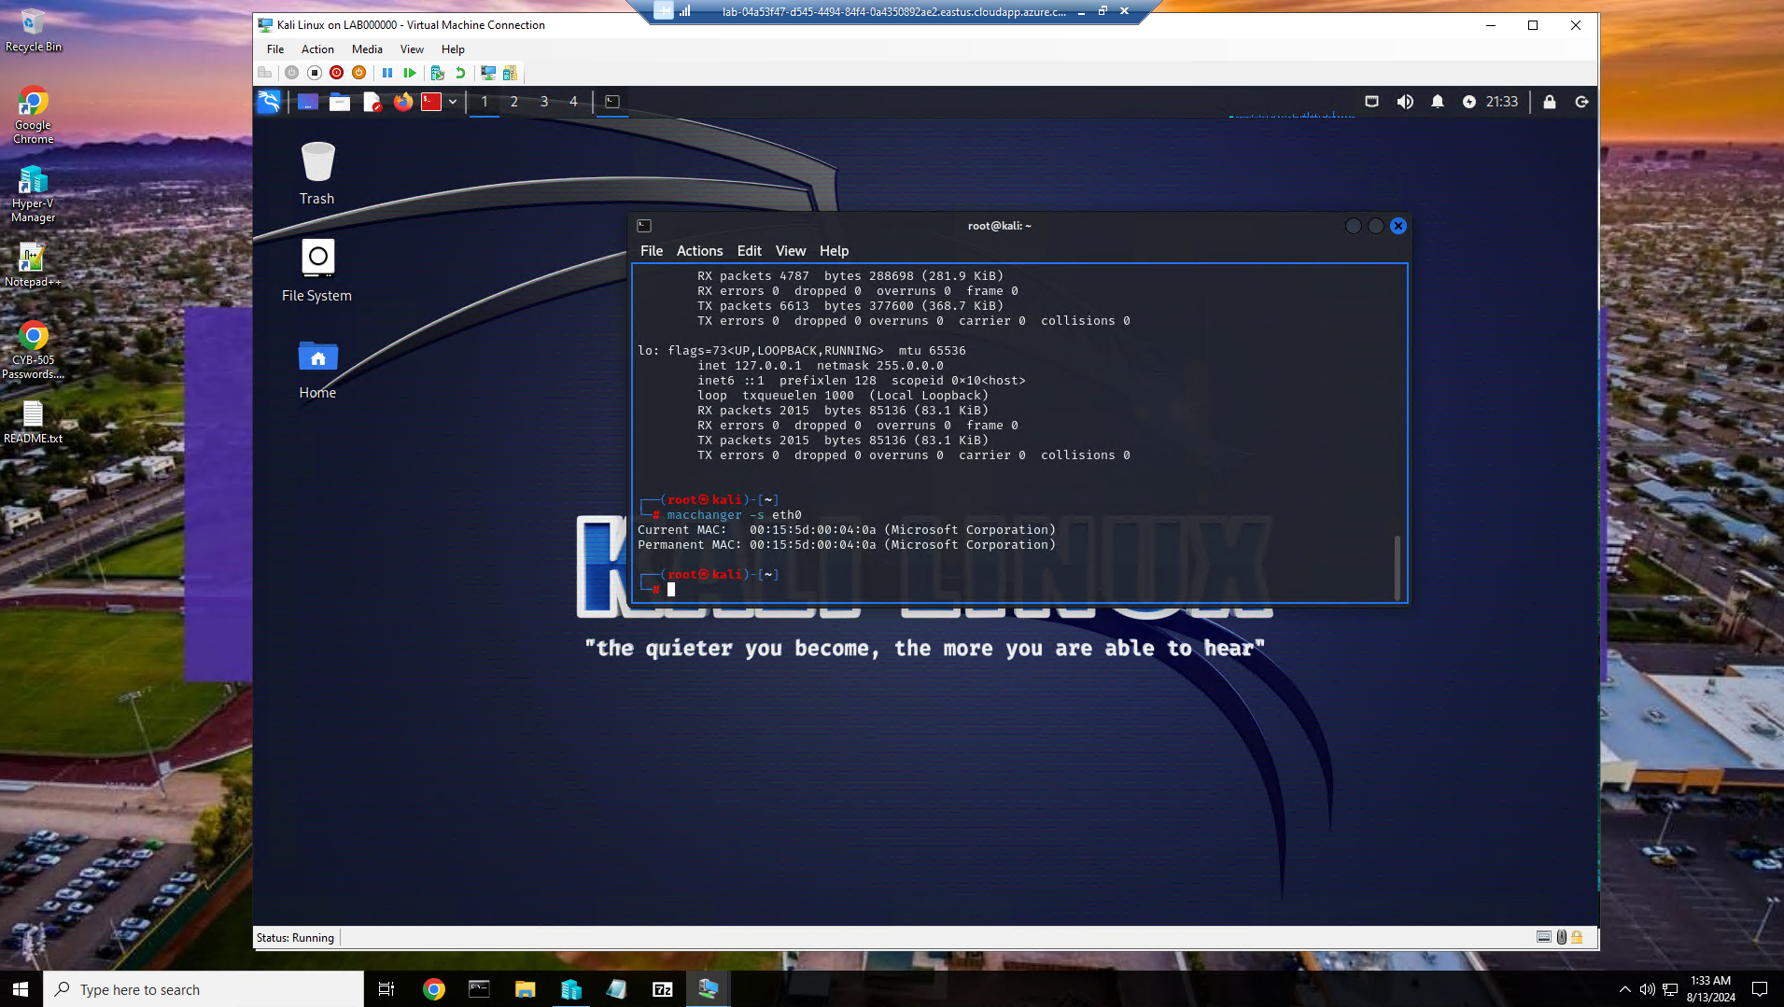

Current mac address of the Kali Linux server

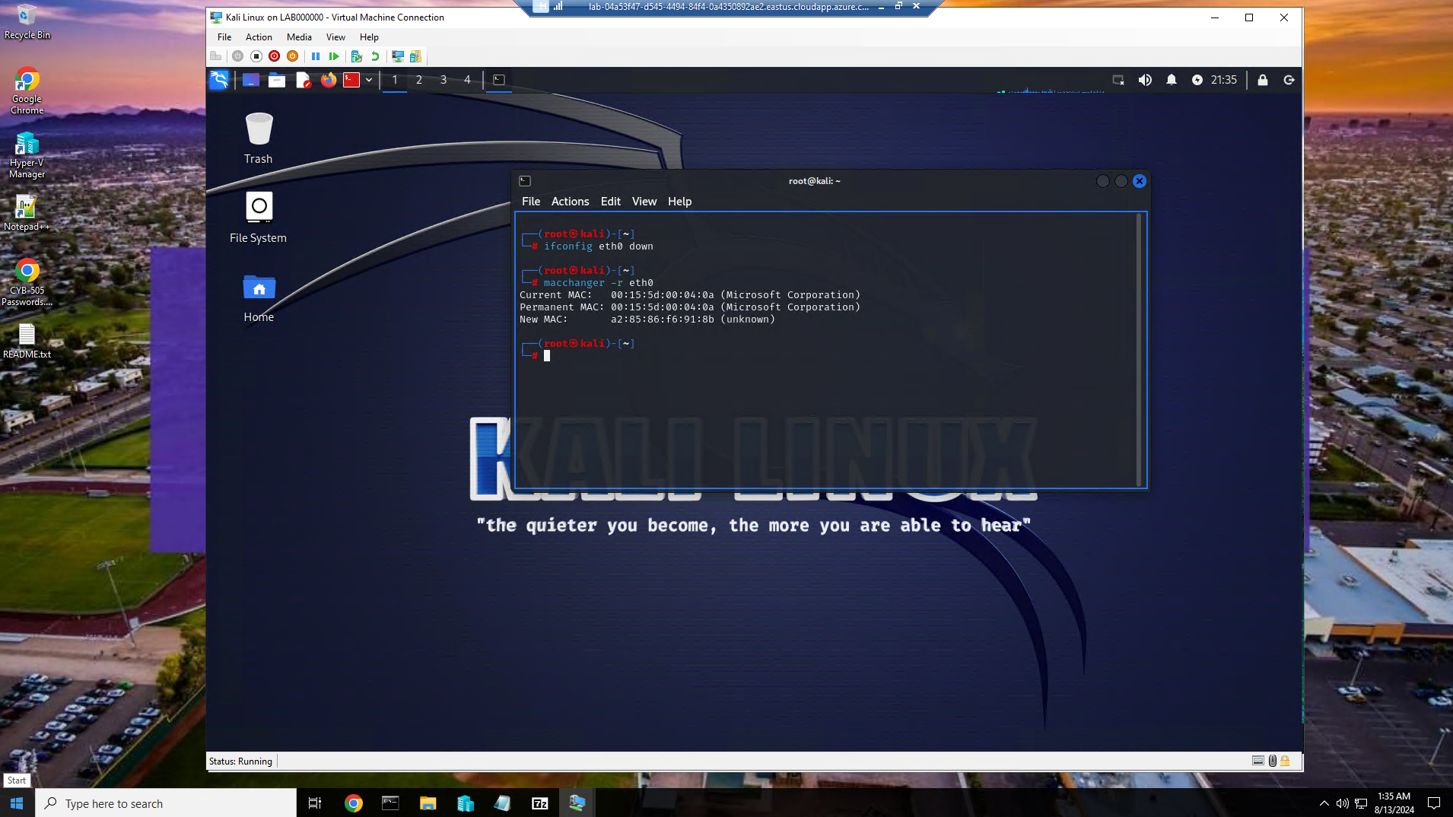

Mac address changed as shown from Kali Linux server.

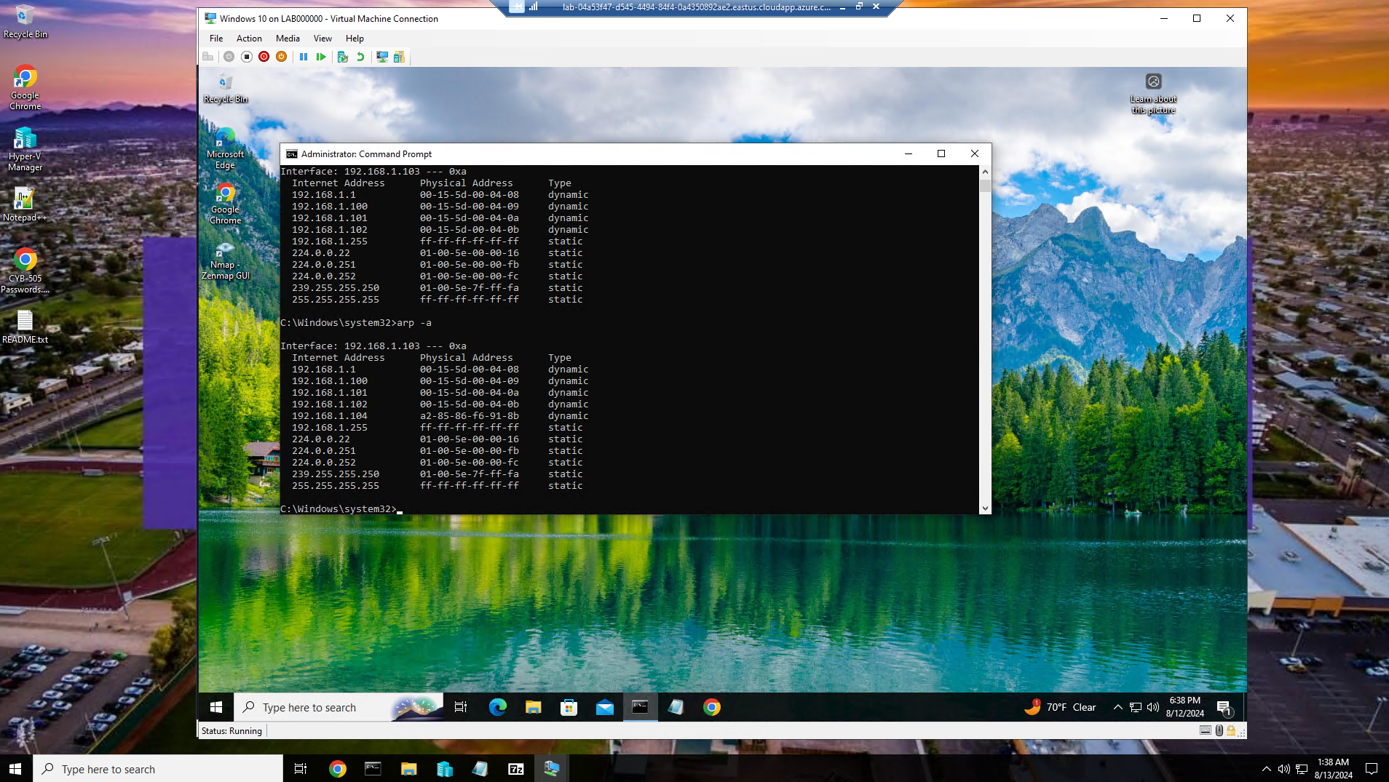

Kali mac address changed as shown from ARP table on Windows 10 server.

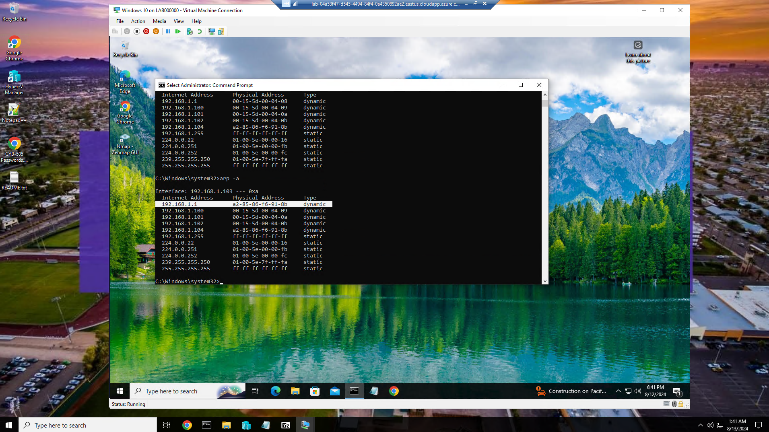

Mac spoof as shown on ARP table from Windows 10 server

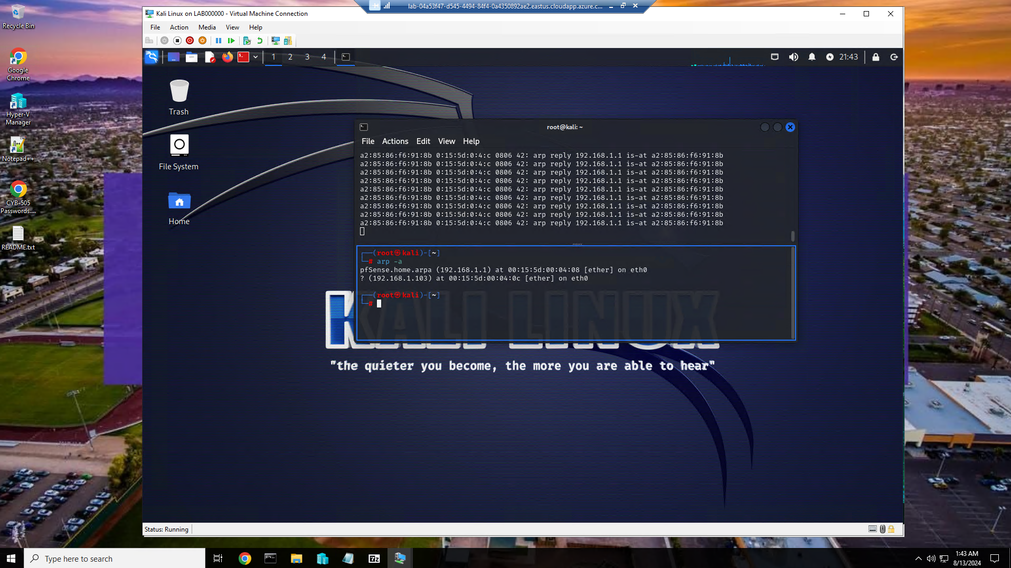

Mac spoof as shown from the Kali Linux server

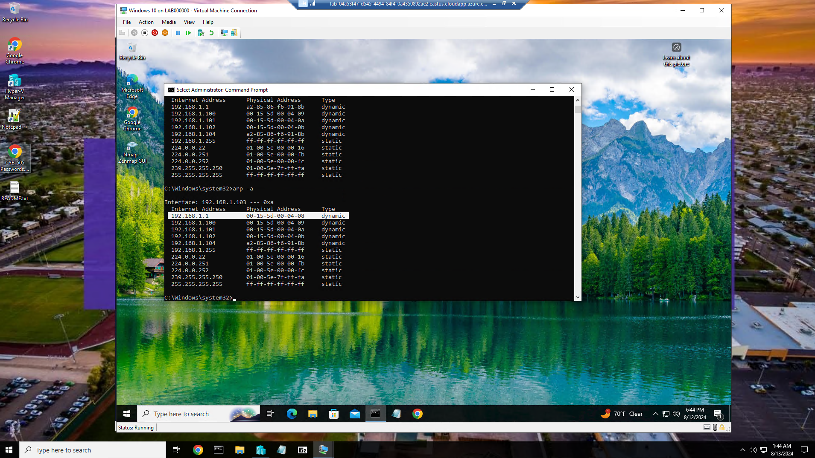

Showing the mac spoof stopped and returned to normal from the Windows 10 Server

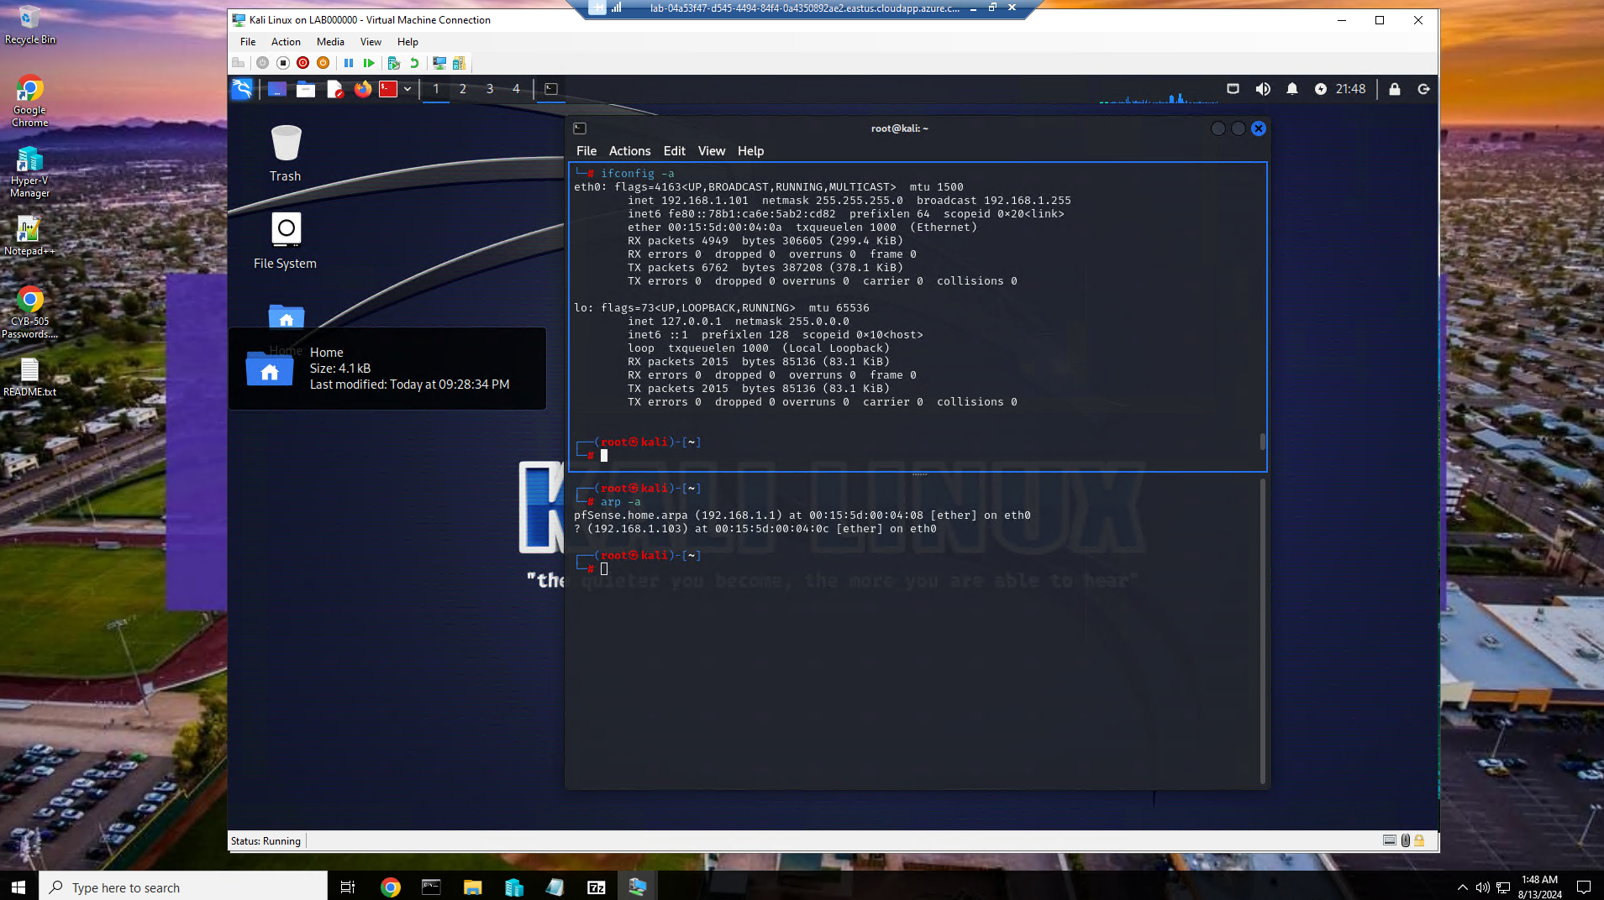

Returning the mac address of the Kali Linux server

Part 2:

Provide your current MAC address and your IP address.



Current MAC address is 9c-34-26-b0-95-bf and ip address ia 192.168.0.19

Provide the name and IP address of a website (not GCU.edu).

[www.nike.com](http://www.nike.com) has an ip address of 99.86.91.43

Define a MAC address, ARP, DNS, and spoofing in your own words.

A MAC address is a unique identifier assigned to network interfaces for communication on a network. It is a hardware address associated with a network adapter and is used to identify devices at the data link layer of a network.

ARP is a protocol used to map IP addresses to MAC addresses on a local network. It helps devices find each other's MAC addresses based on their IP addresses to facilitate communication within the same network.

DNS is a system that translates domain names into IP addresses that computers use to locate and connect to websites or other online services. It acts as a phonebook of the internet.

Spoofing is the act of falsifying information to deceive a system, network, or user.

Explain why conducting an attack on your roommate or place of work without their permission is illegal or unethical.

Conducting cyber attacks without permission is not only illegal due to violating cybersecurity laws but also unethical because it disregards consent, causes harm, breaches trust, and goes against fundamental ethical principles. It is essential to always seek proper authorization and adhere to legal and ethical guidelines when performing any form of cybersecurity testing or activities.

Explain why conducting an ARP attack on your virtual machine is legal.

Conducting an ARP attack on your virtual machine can be legal under certain conditions, especially when done for educational or testing purposes with proper authorization.

Legal Consent:

If you own the virtual machine or have explicit permission from the owner to conduct security testing, including ARP attacks, then the activity is legal. Consent plays a crucial role in determining the legality of such actions.

Educational Purposes:

Conducting ARP attacks on your virtual machine for educational purposes, such as learning about network security vulnerabilities and defenses, is often considered legal. Using these attacks to enhance your understanding of cybersecurity is a valid reason.

Authorized Testing:

In some cases, organizations or individuals may authorize penetration testing or security assessments that involve ARP attacks on their own systems or virtual machines. As long as the testing is authorized and within the scope of the agreement, it can be legal.

Boundaries of Ownership:

Since the virtual machine is under your ownership or control, you have the right to perform security testing within the boundaries of that ownership. Testing the security of your own systems is generally legal as long as it does not violate any terms of service or agreements.

No Harm Intended:

When conducting ARP attacks on your virtual machine, the intention is not to cause harm to others or disrupt networks outside of your control. As long as the attack is contained within your virtual environment, it is less likely to have negative consequences.

Identify the sniffing, spoofing, and session hijacking components of an ARP poisoning attack.

 Sniffing is the process of intercepting and capturing network traffic to analyze it for sensitive information

Spoofing involves impersonating another device or forging information to deceive targets.

Session hijacking is the act of taking over a valid session between two parties without their knowledge.

Sniffing is used to capture network traffic for analysis.

Spoofing involves falsifying ARP messages to redirect traffic through the attacker's system.

Session hijacking allows the attacker to intercept and potentially manipulate communications between the victim and other devices on the network.

References:

*ARP Poisoning*. (n.d.). Www.radware.com. https://www.radware.com/security/ddos-knowledge-center/ddospedia/arp-poisoning/#:~:text=ARP%20Poisoning%20(also%20known%20as

*ARP Poisoning: Network Manipulation - Kelvin Zero*. (2024, April 3). Kelvin Zero. https://kzero.com/resources/guides/cyberattack/arp-poisoning/#:~:text=Legal%20and%20Ethical%20Implications

Folger, J. (2020). *Spoofing*. Investopedia. https://www.investopedia.com/terms/s/spoofing.asp

Fortinet. (2023). *What Is Address Resolution Protocol (ARP)*. Fortinet. https://www.fortinet.com/resources/cyberglossary/what-is-arp

*Legal Considerations when Gathering Online Cyber Threat Intelligence and Purchasing Data from Illicit Sources 1*. (n.d.). https://www.justice.gov/criminal/criminal-ccips/page/file/1252341/dl

*Men&Mice — What is DNS? (Domain Name System)*. (n.d.). Men&Mice — What Is DNS? (Domain Name System). https://www.menandmice.com/glossary/what-is-dns

*What is a MAC Address?* (2019). WhatIsMyIPAddress.com. https://whatismyipaddress.com/mac-address